Case Study Assignment

Kristen Townsend
Department of Curriculum and Instruction, East Tennessee State University
READ 3500: Differentiated Literacy and Language Instruction
Dr. Jody LaShay Wood
April 28, 2024

Introduction:
The objective of this case study was to collaborate with a floundering learner who was performing below grade level expectations, to improve and ideally raise their abilities to meet academic expectations. The interventions in this study took many forms and the scope included pre-assessments, didactic activities, and post remediation assessments to discern what level of growth occurred during these sessions. To preserve the anonymity of the student, I will be referring to her with the pseudonym Anna Heeler.
Student Demographics:
Name | Home Language | Age | Grade | Interests | Academic Strengths
Anna Heeler | English | 6 years old | 1st | Reading  Bluey  Dogs  Pokémon  Frozen | The student enjoys and performs best in science content areas.

Interest Inventory Survey:
One student interest survey and four reading interest surveys were administered to Anna (see appendix Figures 1, 2, 3, 4, & 5). The survey activity showed me that Anna enjoys reading overall. She has access to a large library of books at home and her parents highly encourage their children to read as much as possible. In addition to her home collection, she also enjoys visiting the school and public libraries. Anna indicated that she likes to read in her free time and prefers to read in her own head, or have others read to her. Anna answered that she understands most of what she reads but did so with hesitation. She seems to love reading but is stymied by a lack of confidence in her reading abilities. This is likely why she does not want to read aloud.
Anna expressed an interest in a wide variety of subjects and genres. Her favorite genre to read is fiction. She enjoys reading stories about knights and dragons, space aliens, magic, and spooky stories. When asked for her favorite topic to read about, she chose ghost stories. Despite her love of fiction, Anna was also interested in many non-fiction topics. She expressed interest in reading about adventure stories with mountains, famous people like George Washington, cats & dogs, faraway places, dinosaurs, and cars. Anna did not show any particular dislike of the presented topics, but she was not interested in books about sports or food.
Diagnostic Assessments:
Words Their Way Primary Spelling Inventory ~
The first assessment I administered to Anna was the Words Their Way Primary Spelling Inventory (see appendix, Figures 6 & 7). Anna spelled 10 out of the 26 words correctly and scored 36 out of 56 feature points. Her total score, including correctly spelled words and feature points, was 46 out of 82. Anna achieved all seven feature points in the Initial Consonant, Final Consonant, and Short Vowel categories. This shows a successful ability to spell these features consistently. She scored 5 out of 7 in the Digraphs category, indicating a need for review of this material. Next, she scored 6 out of 7 in the Blends category, which also indicated a need for review. For the remaining categories she scored 3 out of 7 in Common Long Vowels, 0 out of 7 in Other Vowels, and 1 out of 7 in Inflected Endings. In reviewing Anna’s results, we see that she first lacks two feature points in the category of Digraphs; when combined with the missing point in the Blends category, this indicates that Anna could benefit from a review of Digraphs and Blends (with particular focus on ‘th,’ ‘ck,’ and ‘cr’). Once we complete this review, our tutoring should move on to the more advanced categories in the order of Common Long Vowels, Other Vowels, and Inflected Endings.

Bluey Story Writing Prompt ~
I created a story prompt centered around Anna’s favorite T.V. show, Bluey (see appendix Figure 8). The sheet prompted her to author a Bluey story of her own imagination. She asked me if she could instead write about her favorite episode of Bluey, called “Teasing.” I encouraged her to do so, because I wanted an accurate representation of her writing for analysis. Aside from one initial spelling question, regarding the title, she drafted the story without assistance. Anna wrote until she felt too tired to continue and completed an approximately one page story.
I was impressed at her level of recollection regarding this episode. She wrote a moment by moment description telling the reader what the characters were doing. The dialogue was verbatim to what the characters said in the episode. Unfortunately, the story did not extend further than the initial setting and dialogue of the characters and covered only 35 seconds of the seven minute episode. She wrote in short sentences that “told” rather than “showed” the reader what was happening. Many of her words were spelled phonetically versus orthographically. She spelled the word teasing as “teezzing,” “teazing,” “teeing,” and “tizing.” The word was never spelled the same way twice, despite me giving her the correct spelling at the start of the exercise (which was at the top of the paper she was writing on). Her story consisted of short sentences, only contained one capital letter, “I,” and lacked all punctuation.
According to the Teachers College Reading and Writing Project’s Rubric for Narrative Writing, Anna scored 27.5 points overall (see appendix Figure 9). This gives her a scaled score of 2.5, which is below expectations for her grade level. According to Tennessee state standards, as well as Anna’s school curriculum, she will require writing intervention, beginning with capitalization and punctuation. She will also need additional tutoring to help her discern key details and learn to incorporate descriptive words into her writing.

Running Record ~
Discerning Anna’s reading level proved to be a challenge. I administered a running record of “Madeline” by Ludwig Bemelmans as our third assessment. While reading “Madeline,” Anna was reluctant to continue reading. She was easily distracted and verbally expressed her disinterest. I offered her gentle encouragement and asked her to please continue, assuring her that I would read her favorite story to her afterward. She read and would look at me for approval after difficult words. I praised her as she sounded them out and there was an ascertainable increase in both her speed and confidence.
The portion of “Madeline” I had Anna read consisted of 125 running words and Anna completed it with a total of 16 errors and 2 self-corrections. 9 of the errors were words I had to pronounce for her and 6 were errors where she gave a different word with the same initial consonant. Anna’s accuracy rate for this running record was 87.2%, which fell short of the goal rate of ≤95%. “Madeline” was clearly above Anna’s level and we needed to choose a different story.
For the next running record, I chose “Pete the Cat SCUBA-CAT,” by James Dean (Level H; see appendix Figure 10). After her expression of disinterest in “Madeline,” I thought she would be more excited about a story that interested her. I also chose the aquatic feline story because I felt the words would provide enough of a challenge to bolster her sense of efficacy yet be within her realm of capability.
Anna was excited to read the new story and asked to read it before I even set it down. I had planned to read the first portion to her, and have her read after a certain point, but she eagerly asked me to read first. We had read many books by this point, and it was incredible to see how motivated she was. She read the first two pages, then I took over until she got to the pages I had selected for her. She read more quickly than with “Madeline,” but still slowly, stopping to decode larger words.
What she lacked in fluency and prosody, she made up for in comprehension. Anna answered comprehension questions for all five running records we completed. She was able to answer all of the questions but needed to rely on pictures for many of them. Not only did Anna not need the pictures for Dean’s book, but she asked me a comprehension question of her own. When I answered correctly, she praised me for doing a “good job.” This was indicative of her connection and comprehension of the story. I had thought the seafaring cat would be the story to get us to an accuracy rate of ≤95%, but this was not the case. Anna made 9 errors and 1 self-correction while reading the story portion of 122 running words. 7 of the words were provided by me, when she could not decode them, she repeated 1 partial line, and substituted a word for another with the same initial consonant sound. Anna’s accuracy rate for this book was 92.6%.
After the Pete book, we completed three other running records in an attempt to achieve a ≤95% accuracy rate. Anna next read “Trees” by Olivia Ramos (Level G). She made 10 errors out of 164 words, resulting in an accuracy rate of 93.9%. After that we moved on to “Castles” by “Michele Dufresne” (Level F). Anna read this book with an accuracy rate of 86.5%, making 10 substitution errors and 2 decoding errors. Finally, she read “Runaway Sandy” by Nicolas Thilo (Level E). She made 4 substitution errors, 1 mispronunciation error, and 5 self-corrections. This gave her an accuracy rate of 94.8%, which was the closest we had been to the initial goal of ≤95%.
However, as we worked through each assessment, I noticed signs that the goal accuracy rate should not be the sole determining factor of Anna’s reading level. Anna would miss many words in these stories, then pronounce them correctly later in the book. She also read more accurately and more effortfully when her confidence and interest levels were up. For instance, in the book “Castles,” she struggled with most of the key vocabulary words. However, when she finished the story, she turned to the vocabulary bank on the next page and read every word perfectly, without prompting. When she does not know a word or feels unconfident, she will substitute one word with the same initial consonant sound for another (ex: windmills for windows). She makes assumptions of what certain words are based on some of the letters she sees.
After analyzing numerous factors such as rate, prosody, fluency, accuracy, comprehension, and more, it appeared that Anna's instructional reading level was at an H. “Pete the Cat SCUBA-CAT" presented a sufficient number of longer words to provide a challenge for her, occasionally requiring decoding, yet she managed to read and comprehend the story effectively overall. I do not feel it would be accurate to determine her reading level solely off the accuracy rates reflected in these running records. Reading and comprehension can sometimes be more complex in their intricacies.
Interventions:
Word Sorts~
Standard: 1.FL.PWR.3 Know and apply grade-level phonics and word analysis skills when decoding isolated words and in connected text.
a. Know the sound-spelling correspondence for common consonant digraphs.
c. Know the final –e and common vowel team conventions for representing long vowel
sounds, including r controlled vowels. (See appendix Figure 11)
Objective 1: The student will demonstrate proficiency in recognizing and applying the sound-spelling correspondences of the digraph 'th', and the blend 'cr', through accurate categorization of word sort cards.
Objective 2: The student will demonstrate proficiency in distinguishing between different vowel sound patterns, including short 'a' sounds, CVCE (consonant-vowel-consonant-e) words, and long 'a' vowel teams (e.g., 'ai'), through accurate categorization of word sort cards.
Procedure:
The assessment results from the WTW Primary Spelling Inventory indicated that Anna is currently in the late Letter-Name Alphabetic Stage. However, the results also indicated that, with review, Anna will be ready to move into the Within Word Pattern Stage. In order to make this change, Anna needed to review the digraph 'th', and the blend 'cr'; we began with objective 1 (see above). I created word sort cards (see appendix Figure 12) that used images to represent words that started with either ‘th’ or ‘wh’ digraph for Anna to sort and distinguish between (ex: whale vs thumb or wheel vs thunder). For the ‘cr’ blend, anna sorted cards that contained words starting with the ‘cr’ and ‘cl’ blend to achieve the same goal. Anna was able to correctly sort all of the cards with little additional discussion or intervention.
This made it clear that Anna was ready for the Within Word Pattern Stage. Because of this, I decided to continue our focus onto objective 2 (see above). One of the vowel teams she needed practice with was the long ‘a’ sound comprised of the ‘ai’ vowel team. This vowel team was one that she noticeably struggled to decode throughout all of our readings. I chose to focus on this team to improve Anna’s decoding during future reading. To address this, Anna sorted the WTW word sorts (see appendix Figure 13) that distinguish between different vowel sound patterns, including short 'a' sounds, CVCE (consonant-vowel-consonant-e) words, and long 'a' vowel teams (e.g., 'ai'). I started by explaining the categories thoroughly and made sure they were labeled in a way that Anna clearly understood. (ex: I added the word bump to the CVCE category label, after Anna proudly taught me the rule that when a word ends in ‘e’, the vowel moves over and bumps ‘e’ on the head, and in its confusion, the ‘e’ says the vowel’s name) I wanted to clearly label the categories and encourage the parts of literacy that Anna was excited about. I asked Anna to sort the words and initially let her sort them without providing guidance. She sorted 8 of the 21 words correctly and 13 of the words incorrectly. We discussed the graphophonic cue systems behind the words and related how these rules were like a secret code that helps us figure out words when reading. We played detective and used what Anna already knew about the words in front of her to decode the words and discern their appropriate categories.
Closure:
By the end of our activity, Anna was able to sort all of the words correctly without assistance. She was also able to explain why each word went into that specific category. During our last sorting session, Anna had sorted 3 of the 21 words when her teacher came out to speak to me. Though I only spoke to her teacher for one minute, when I turned around, Anna had sorted the remaining words perfectly. The amount of improvement she made during this activity was incredible, and I was immensely proud of her effort and growth.

Digraph Discrimination Activity~
Standard: 1.FL.PWR.3 Know and apply grade-level phonics and word analysis skills when decoding isolated words and in connected text.
a. Know the sound-spelling correspondence for common consonant digraphs. (See appendix Figure 11)
Objective: The student will demonstrate mastery in recognizing and differentiating words with the 'ck' digraph by correctly identifying and circling all instances of 'ck' within a given text, while also distinguishing that 'ck' digraphs occur only at the end, or in the middle of words, not at the beginning.
Procedure:
The WTW spelling inventory also indicated that Anna experienced confusion with where the ‘ck’ digraph should be placed within a word. This was not apparent from the scoring of the test but became obvious when analyzing her written words from the spelling test. She began three words with ‘ck’ during the spelling test. She spelled the word coach as “ckoche,” crawl as “ckralld,” and camped as ckempt. The main focus of our lesson was to highlight how the ‘ck’ digraph only occurs in the middle of a word (such as with morphemes) or at the end. To start our session, I read aloud one of Anna's favorite books, entitled “Little Joe Chickapig” by Brian Calhoun (see appendix Figure 15). The book was several levels above Anna’s reading level, so I read it aloud as she followed along with her finger. The ‘ck’ digraph appears over twenty times throughout the book; as Anna followed along, she drew an imaginary circle over the word every time it appeared. We discussed the placement of the ‘ck’ digraph throughout our reading.
Next Anna read aloud a one page story called “The Stuck Truck” by B. Marker (see appendix Figure 16). The story was intended to give students practice with the ‘ck’ digraph, which appears in the story ten times. The story contains sentences such as “I do not have to be with the other trucks,” said a big, black truck” (Marker, 2022). As Anna read the story, she circled every word containing ‘ck.’ To close the lesson, we again discussed the placement of the ‘ck’ digraph, as well as examples of words that begin with ‘c’ or ‘k’ individually.
Closure:
Anna made great progress throughout our tutoring session. She began by thinking that the ‘ck’ digraph sometimes belonged at the beginning of the word and was uncertain why it could not be used in that way. As we discussed how to appropriately use the digraph and practiced with readings, she began to understand and identify how the letters should be used. By the time we got to “The Stuck Truck,” she was able to circle and identify all of the words containing the ‘ck’ digraph and was able to explain to me in her own words where we are supposed to find the digraph within a word.

Writing, Outlining, and Editing Task ~
Standard 1: 1.FL.SC.6 Demonstrate command of the conventions of standard English grammar and usage when speaking and conventions of standard English grammar and usage, including capitalization and punctuation, when writing.
j. Capitalize names of people and dates.
k. End sentences with correct punctuation. (See appendix Figure 11)
Standard 2: 2.FL.SC.6 Demonstrate command of the conventions of standard English grammar and usage when speaking and conventions of standard English grammar and usage, including
capitalization and punctuation, when writing.
k. With prompting and support, link sentences into a simple, cohesive paragraph with a
main idea or topic. (See appendix Figure 11)
Objective: The student will demonstrate proficiency in organizing thoughts and ideas cohesively by answering questions about a coloring picture according to an outline, and subsequently composing a paragraph using their responses. Additionally, the student will apply standards for sentence structure, capitalization of sentences and proper nouns, and correct punctuation.
Procedure:
After reviewing Anna’s writing assessment and speaking with her teacher, it became clear the most critical areas of focus were capitalization of sentences and proper nouns, correct use of punctuation to end sentences, and composing a paragraph using linked sentences and proper sentence structure. I additionally wanted to expand Anna’s elaboration abilities. According to the Teachers College Reading and Writing Project’s Rubric for Narrative Writing, Anna's initial writing assessment resembled the lower level of "The writer put more and then more on the page." My goal was for Anna to brainstorm and incorporate additional details into her story, progressing towards the criteria of "The writer’s story indicated who was there, what they did, and how the characters felt." I began by reviewing Anna’s writing assessment with her. We reviewed the importance of using proper capitalization, the kind of words that must be capitalized, and how each sentence must end with the proper punctuation.
Next we worked with a Bluey themed writing outline (see appendix Figure 18) that corresponded to a Bluey coloring page (see appendix Figure 17). We colored the page together and discussed what was going on in the picture. After coloring, I asked Anna the questions on the outline, and she wrote her answers. The outline contained the questions:
- “What do we see?”
- “Who do we see?”
- “What are our characters doing?”
- “How is the weather?”
- “What is your favorite part of the picture?”
I gave Anna a Bluey writing page with the prompt, “Let’s write our very own Bluey story!” (see appendix Figure 19) I read her the questions from the outline, and she read her answers aloud. I asked her to form these as a sentence and say it aloud, just as if she was talking to someone. She said a sentence and I had her write it down on the final writing page. We continued this throughout the remainder of the outline questions until she had written a paragraph addressing them all. Then we discussed how editing is an important part of the writing process. She read her sentences aloud, and I asked her if anything was missing regarding sentences that needed capitalization or punctuation. Anna quickly assessed these sentences and made the necessary corrections without further prompting.
Closure:
Anna showed tremendous progress at multiple points of this activity. Her initial writing assessment contained no punctuation and only one capital letter. After reviewing syntactical rules for punctuation and capitalization, Anna completed every outline question using these conventions appropriately where needed. She did not write in complete sentences here, but ended every thought and idea with a period, which was a significant indicator of improvement. Once we moved onto the final writing assignment, Anna’s application of these rules was evident in her writing. While she did not capitalize and add punctuation in every place required, she did apply these concepts correctly in 85% of her writing. Once completed, we reviewed the paragraph together and once I pointed out a sentence that was lacking something, she quickly corrected the issue without further prompting. Anna showed substantial improvement throughout this activity and displayed a thorough understanding of these grammatical conventions.
Post Assessment Results and Case Study Reflection~
I readministered the WTW word sorts that distinguish between different vowel sound patterns, including short 'a' sounds, CVCE (consonant-vowel-consonant-e) words, and long 'a' vowel teams (e.g., 'ai') as my post-assessment activity. During Anna’s initial assessment (see appendix Figure 13), she sorted 8 of the 21 words correctly and 13 of the words incorrectly. She struggled with classifying which word went in each category and had been struggling with the ‘ai’ vowel team throughout all of our readings. By the end of our intervention, she was able to sort the words correctly without assistance. Because this was one of her biggest decoding struggles, I wanted to ensure that she effectively encoded and stored the information within her memory for long-term retention. I waited a week before administering the word sort activity again (see appendix Figure 20). Anna quickly sorted all 21 words into the correct categories without struggle. This indicated considerable improvement in Anna’s decoding capabilities regarding this set of skills.
Once Anna completed this post-assessment, she surprised me by asking to read “Little Joe Chickapig” to me. Even though I had read this book to her at least ten times, I had not deemed it suitable for her to read independently due to its level of difficulty. Once again, she pleasantly surprised me by reading the first two pages, after which we took turns reading the rest of the book aloud, two lines at a time. This confidence and unexpected willingness to tackle such challenging material was inspiring and symbolic of all the progress she had made. I could not have been prouder of her and all that she achieved through her hard work and determination during our sessions together.

Appendix
Figure 1: Student Interest Inventory
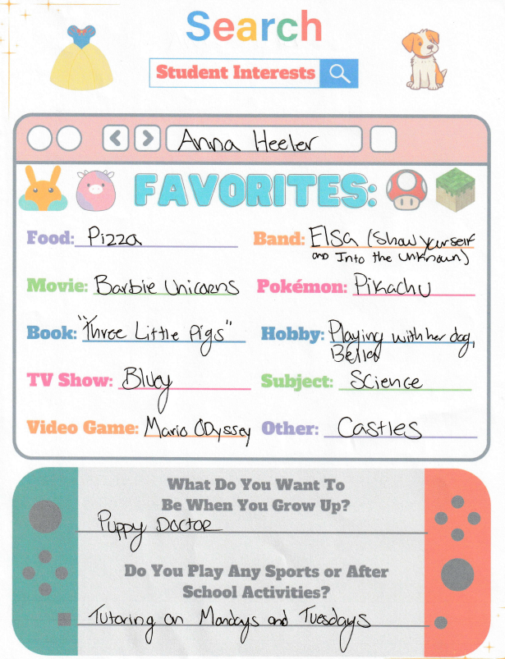

Figure 2: Reading Interest Inventory # 1
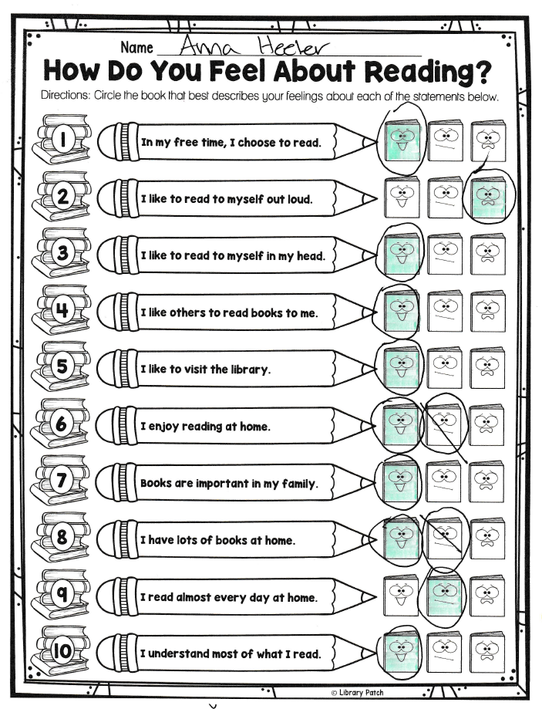
Figure 3: Reading Interest Inventory # 2
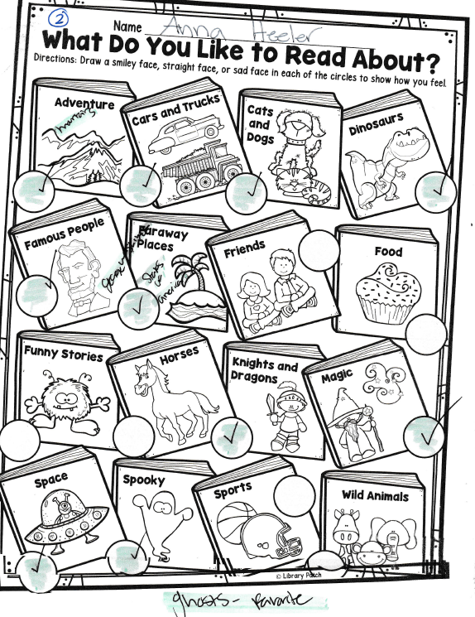

Figure 4: Reading Interest Inventory # 3
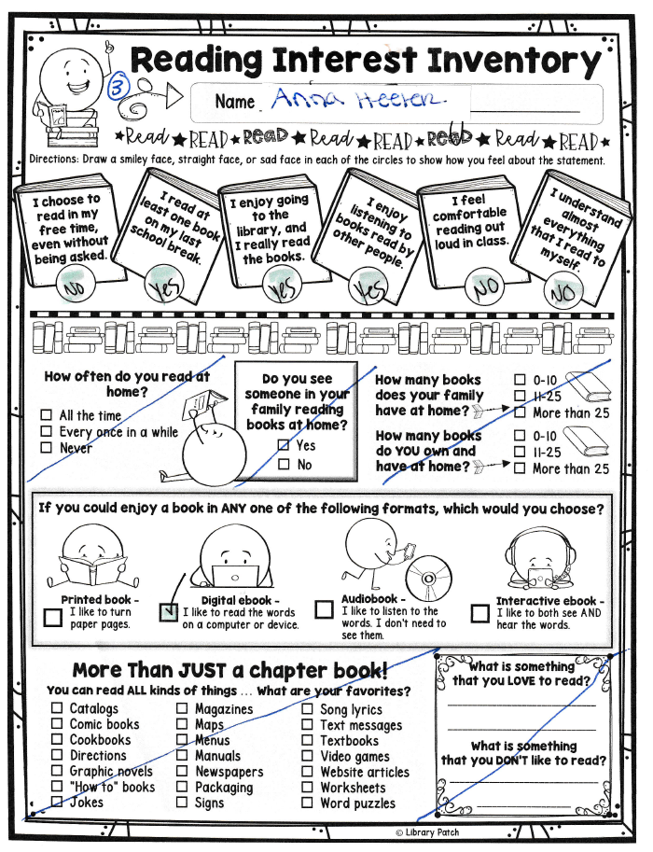
Figure 5: Reading Interest Inventory # 4
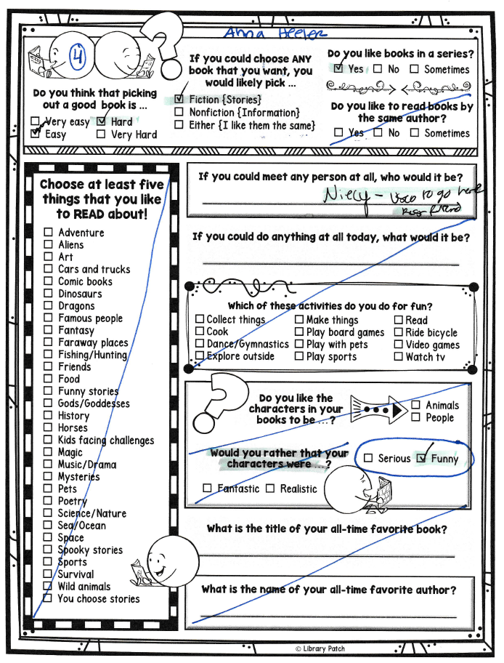
Figure 6: Words Their Way Primary Spelling Inventory Feature Guide
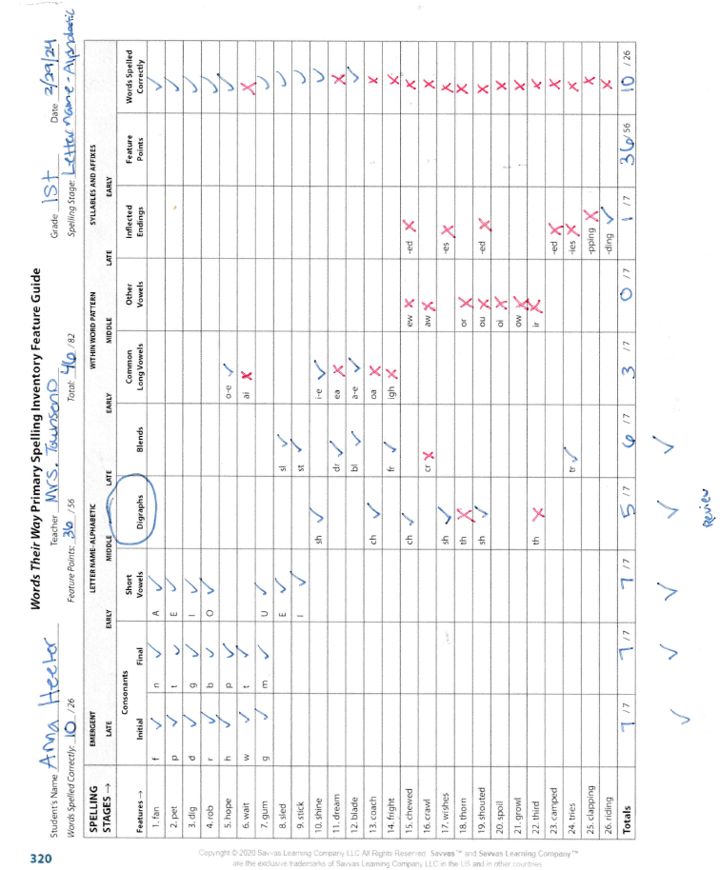

Figure 7: Spelling Test using the WTW Primary Spelling Inventory Word Bank (Page 1 of 2)
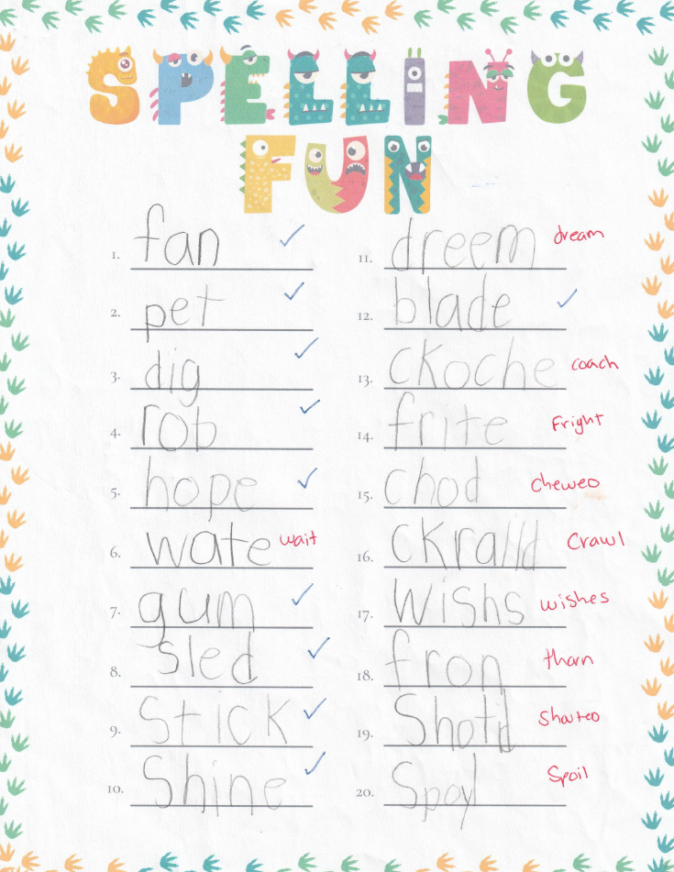
Figure 7 Continued (Page 2 of 2)
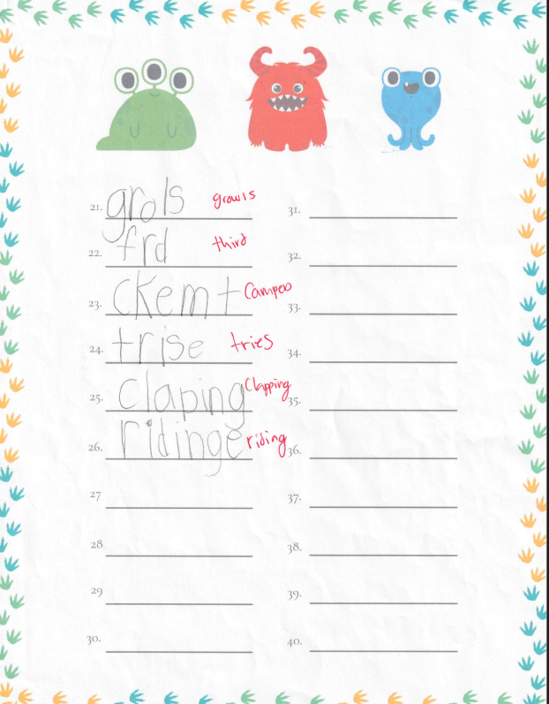
Figure 8: Bluey Writing Assessment (Page 1 of 2)
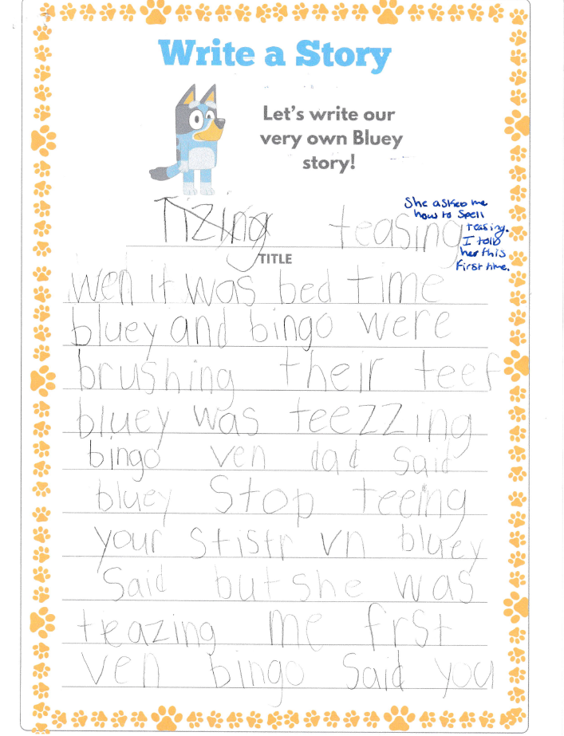
Figure 8 Continued (Page 2 of 2)
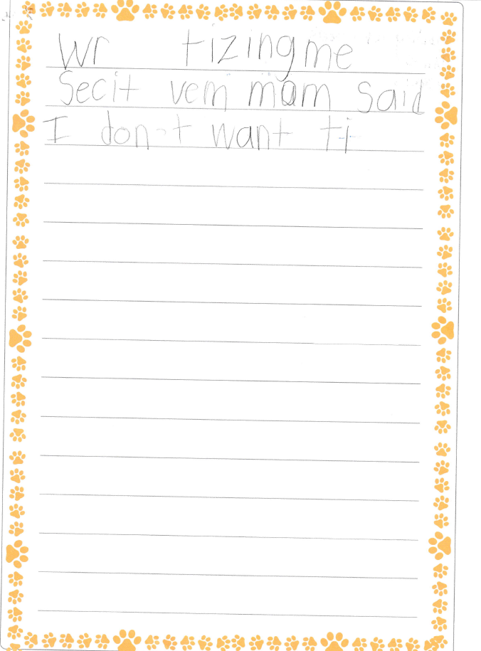
Figure 9: Teachers College Reading and Writing Project – Narrative Writing Rubric (Page 1 of 2)
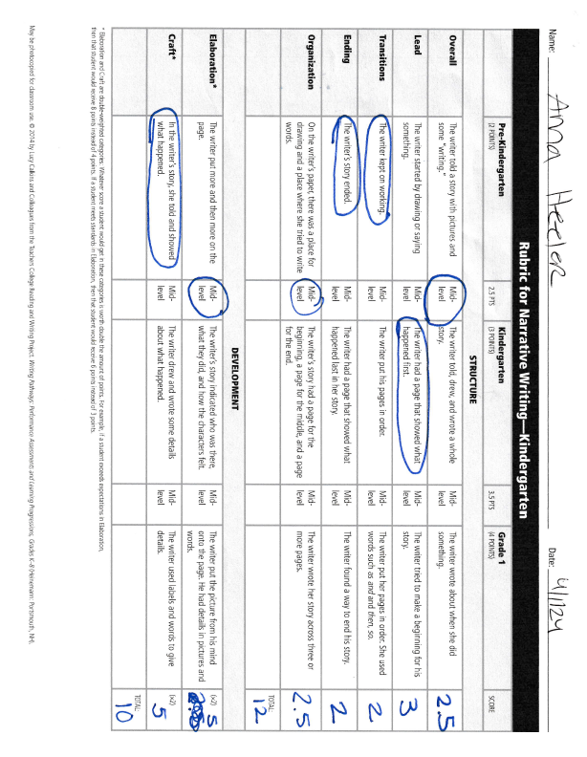
Figure 9 Continued (Page 2 of 2)
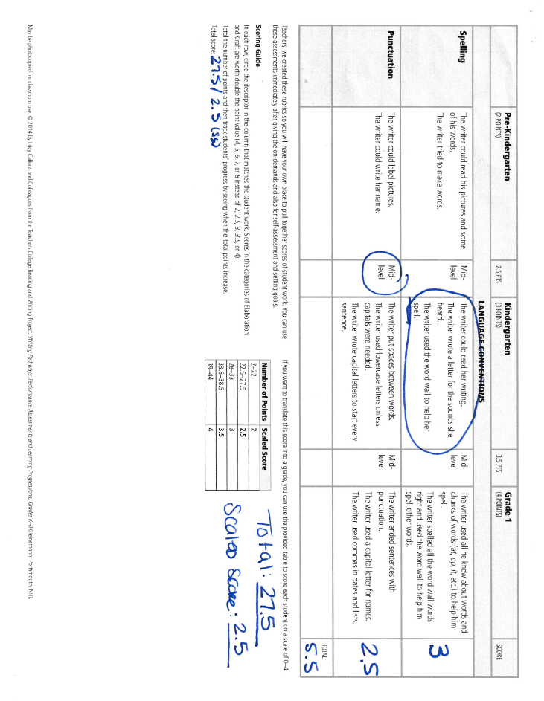
Figure 10: Running Record – “Pete the Cat SCUBA-CAT” (Page 1 of 3)
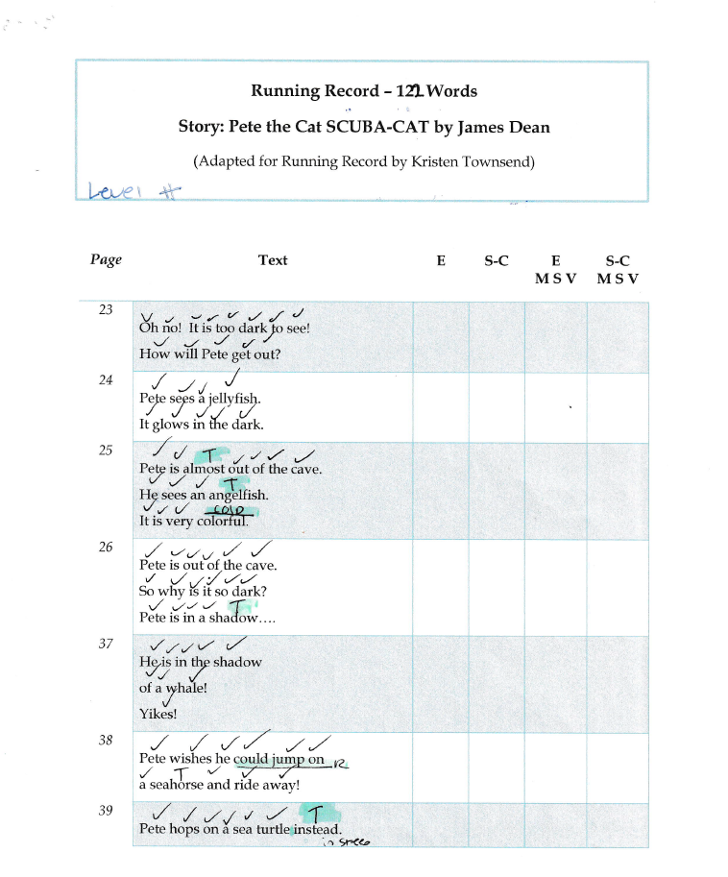

Figure 10 Continued (page 2 of 3)
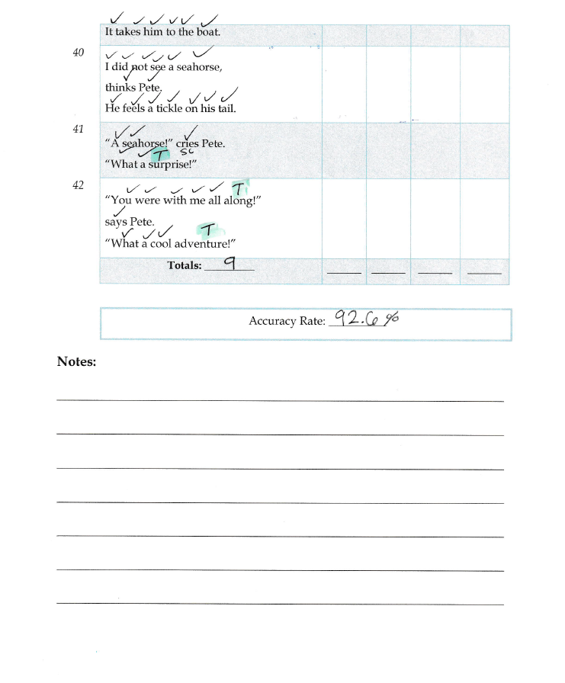

Figure 10 Continued (page 3 of 3)
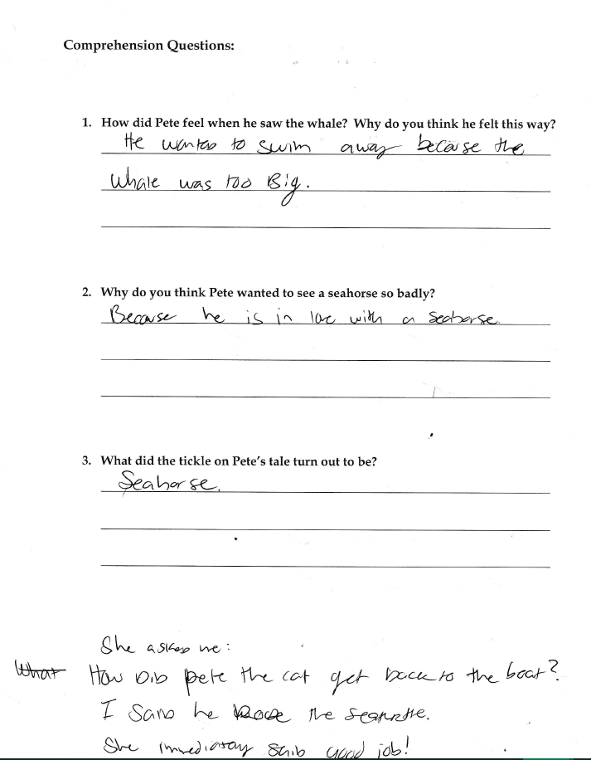
Interventions:
Figure 11: Tennessee ELA Standards for Interventions
Interventions # 1 & 2:
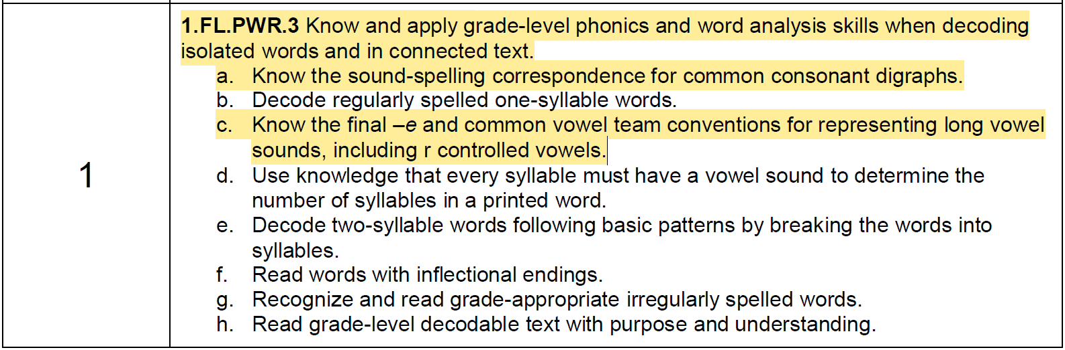
Intervention # 3:
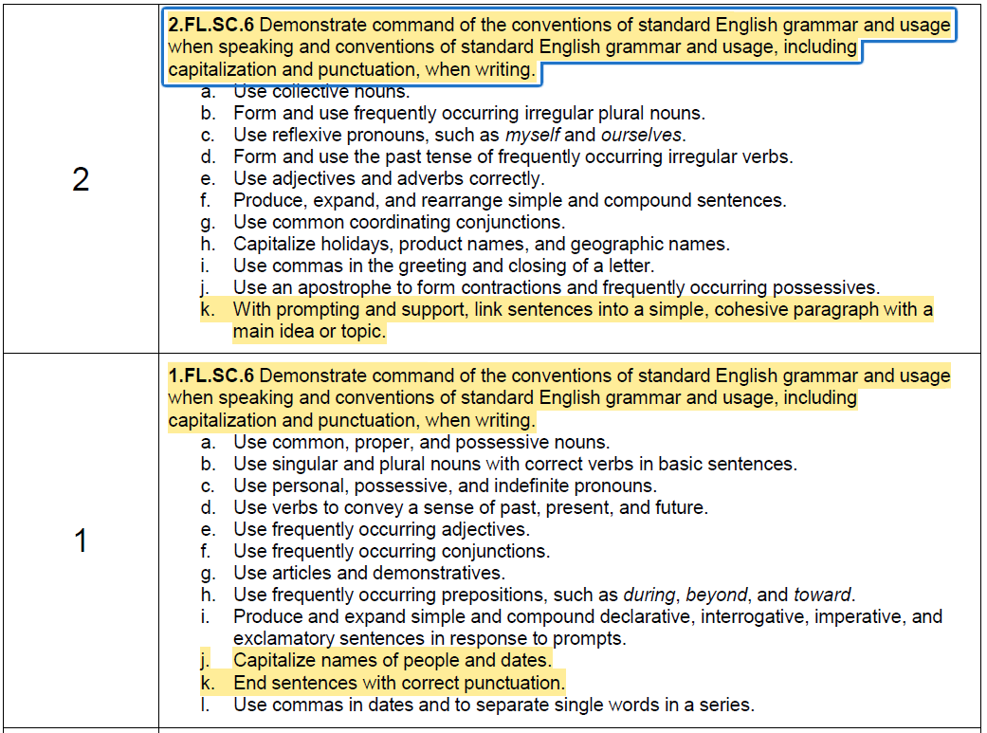

Figure 12: Flashcards – Digraphs: th vs wh & Blends: cr vs cl 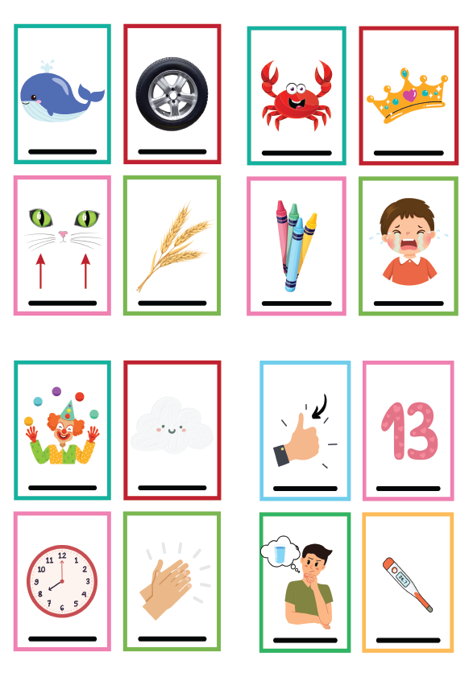

Figure 13 – Word Sort short ‘a’, CVCE, and long ‘a’ vowel team - Initial Attempt (before tutoring)
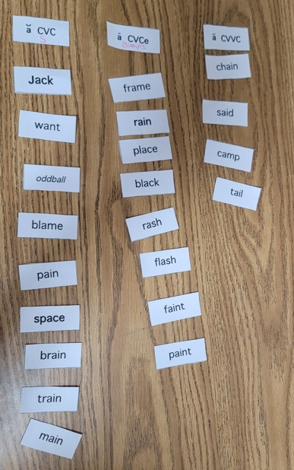

Figure 14: Word Sort short ‘a’, CVCE, and long ‘a’ vowel team - After Discussion & Intervention
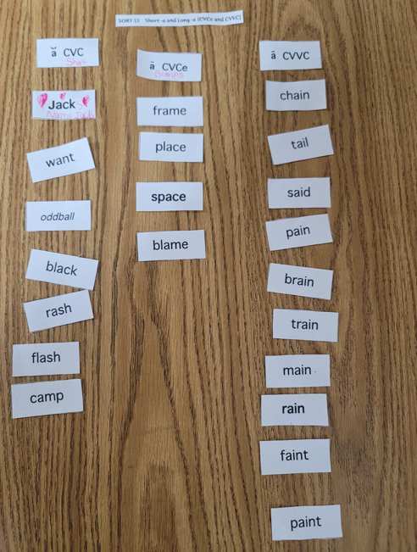

Figure 15: “Little Joe Chickapig” – Read aloud and Digraph Distinction Intervention
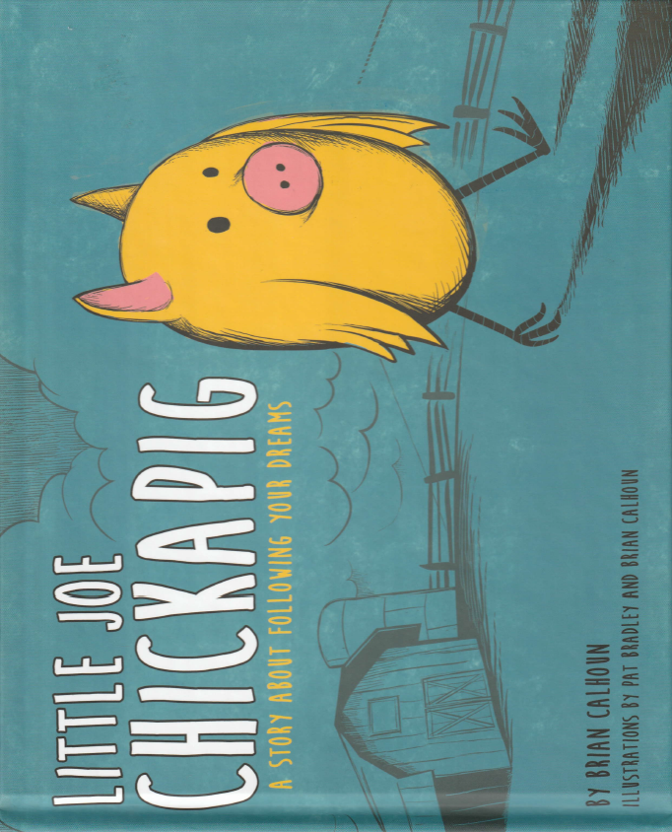

Figure 16: “The Stuck Truck” – Digraph Distinction Intervention
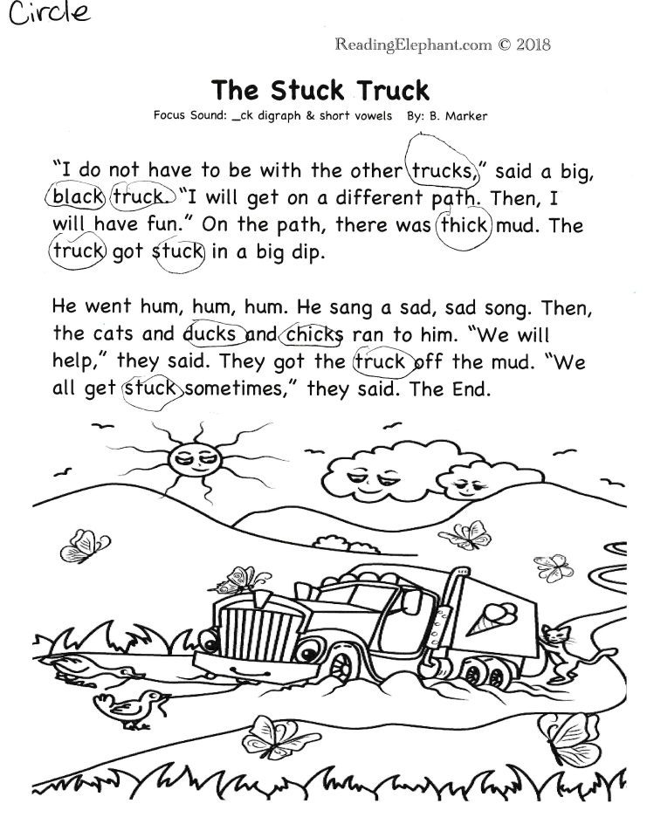
Figure 17: Bluey Coloring Page for Writing Intervention
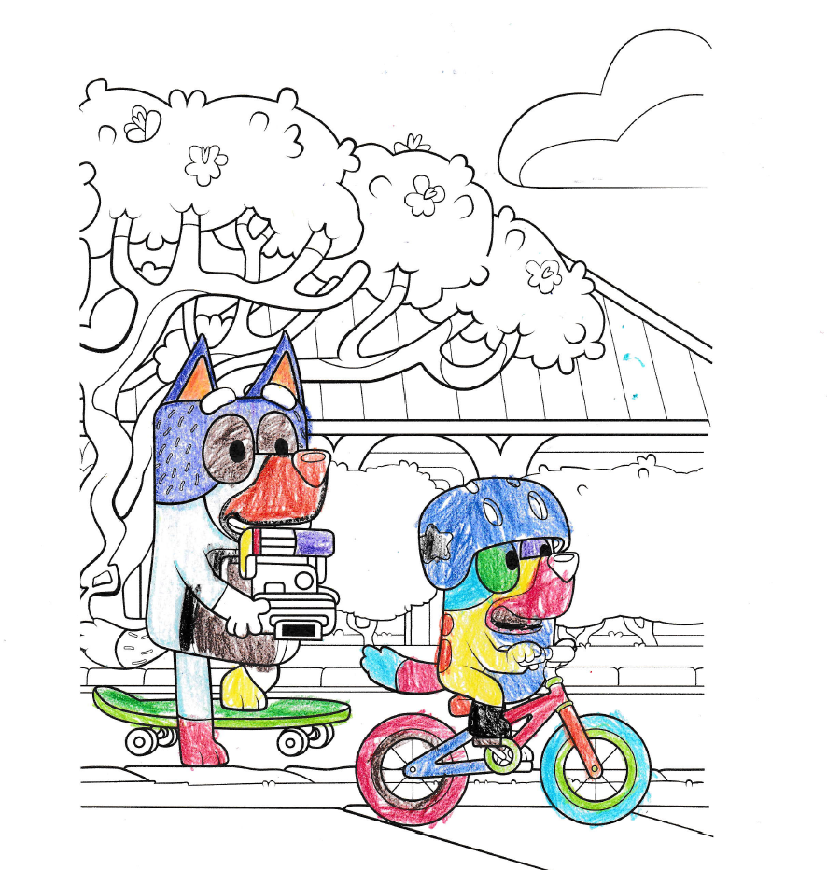

Figure 18: Bluey Outline for Writing Intervention
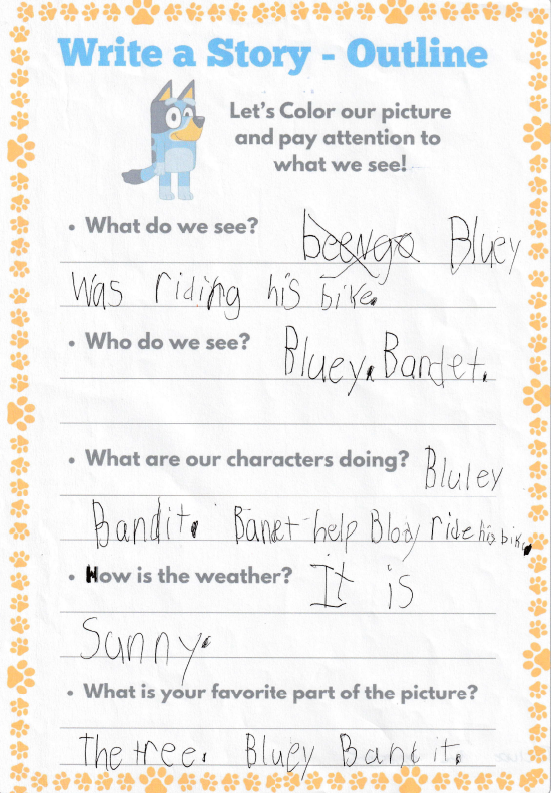
Figure 19: Bluey Coloring Page for Writing Intervention
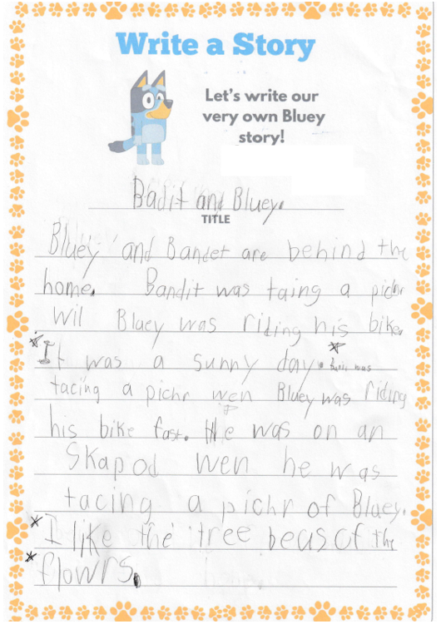

Figure 20: Word Sort short ‘a’, CVCE, and long ‘a’ vowel team – Post Assessment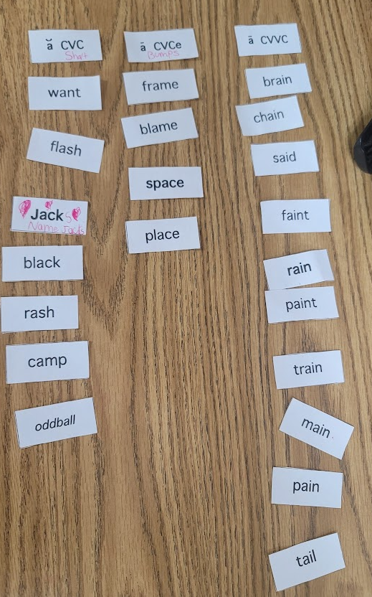
References

Aspinwall, C., Hurford-Jones, H. (Executive Producers). (2018-2024). Bluey [TV series]. Ludo Studio.

Bemelmans, L. (2012). Madeline. National Geographic Books.

Calhoun, B. (2020). Little Joe Chickapig. Studio Fun International.

Dean, J. (2016). Pete the Cat: Scuba-Cat. HarperCollins.

Dufresne, M. (2007). Castles.

Invernizzi, M., Johnston, F. R., Bear, D. R., & Templeton, S. (2017). Words their way: Word sorts for within word pattern spellers (3rd ed.). Pearson.

Lucy Calkins and Colleagues. (2014). Rubric for Narrative Writing—Kindergarten. In Writing Pathways: Performance Assessments and Learning Progressions, Grades K–8 [Report]. Heinemann. https://usd116.org/wp-content/uploads/2019/07/k-narrative-1-1.pdf

Ludo Studio Pty Ltd, BBC Studios, & BBC. (2018). BLUEY. https://assets.readbrightly.com/wp-content/uploads/2020/10/26452_BlueyBackyard_ColoringShts_21.pdf

Marker, B. (2022, February 18). ck Digraph Story- The Stuck Truck (FREE). Reading Elephant. https://www.readingelephant.com/2018/09/13/ck-digraph-story-the-stuck-truck-free/

Ramos, O. (2010). Trees. Houghton Mifflin.

Reading Interest Inventory / Reading Survey for Elementary. (n.d.). TPT. https://www.teacherspayteachers.com/Product/Reading-Interest-Inventory-Reading-Survey-for-Elementary-4727410

Tennessee teachers, administrators, and higher education faculty. (n.d.). Tennessee English Language Arts Standards. https://www.tn.gov/content/dam/tn/stateboardofeducation/documents/massivemeetingsfolder/meetingfiles4/10-20-17_III_J_Non-Substantive_Changes_to_Math_ELA__Science_Standards_Attachment_2_-_ELA.pdf

Thilo, N. (2004). Runaway Sandy. Houghton Mifflin.

